

Instructional Services Task Force
ContentCatalog Object Plan

Version 3.9
October 4, 2009

Table of Contents
1 Introduction 5
1.1 Genesis of this Document 6
1.2 What this Document is Not 6
1.3 Business Case 6
2 Context: An Instructional Asset Retrieval Model 7
2.1 Description of the Model 8
2.1.1 Explanation of the Entities: 8
2.2 Instructional Asset Metadata Retrieval Process 8
3 Use Cases 9
3.1 Use Case 1 9
3.1.1 The Requesting Application 9
3.1.2 The Responder Application 9
3.1.3 Content Retrieval 10
3.1.4 Interconnecting with Existing Resource Search Applications 11
3.2 Use Case 2: Request Instructional Assets 13
3.3 Use Case 3: Technical Overview Use Case 13
4 Open Issues 15
5 ContentCatalog Object Definition 16
5.1 ContentCatalog Definition Table. 16
5.2 XML Example 19
6 Appendices 21
6.1 Glossary: Terms & Concepts in this Document 21
6.2 History 21
6.3 Possible Recommended changes to Education Filter Object 22

Revision History

Version | Date | Author/Organization | Comments
1.0 | 10/20/2008 | Doug Martinson NWEA | First Draft
1.1 | 10/31/2008 | Doug Martinson /Jill Abbott | Review with JillA
1.2 | 11/13/2008 | Doug Martinson | Includes options for review
1.3 | 12/09/2008 | Doug Martinson | Changes and additions based on two ISTF reviews. Major adds:  4.1 Content Catalog usage and  10 Additional Attributes
2.0 | 2/27/2009 | Doug Martinson /Jill Abbott | The result of a working session with Jill with the intent to satisfy the most basic requirement of the learning standard repositories.
2.1 | 3/16/2009 | Doug Martinson /Jill Abbott | Added the LearningResourcePackage as the delivery vehicle.
2.2 | 3/18/2009 | David Longdon | Changed title of document  Updated glossary; want to discuss simple use case that should be incorporated into document.
3.0 | 3/27/09 | David Longdon | Major changes to simplify (?) use case
3.1 | 4/7/09 | David Longdon | Edits and changes based on feedback from 4/2 call.
3.2 | 4/16/09 | David Longdon | Minor changes based on discussion during call. Alex to follow up on issues with AbstractContentPackage and extended query.
3.3 | 6/15/09 | David Longdon | An attempt at distilling proposed “best practices” and outstanding issues from previous versions of this document.
3.4 | ? | ? | ?
3.5 | 7/21/09 | David Longdon | Integrated separate document drafted by Richard Hughes called “Content Catalog Object.”
3.6 | 8/6/09 | David Longdon | Discussed document and made minor changes during ISTF call; post-call--accepted all changes and made editorial changes for clarity.  Updated ISTF Instructional Asset Retrieval Model diagram based on current thinking.  Attempted to make use of terms consistent throughout document.
3.7 | 8/30/2009 | Alex Jackl/CCSSO | Did a pre-final edit run. Re-ordered content and edited the object description to a more final form. Although XML examples aren’t done yet and there are open metadata issues this should be sufficient for an intial review by others.
3.8 | 9/21/2009 | Richard Hughes | Updated ContentCatalog definition
3.9 | 10/4/2009 | Richard Hughes | Modified based on feedback to developer camp meeting. Added example XML.

Introduction

The SIFA Instructional Service Task Force (ISTF) is proposing a new SIF object, the Content Catalog object and “best practices” for searching and retrieving instructional assets. The intended purpose of this object is to facilitate searching for resources. Such searches will be initiated by a requesting application such as a digital learning environment or learning management system. The response to the search response will be served by responder applications such as instructional asset repositories.

This document describes a simple scenario that involves SIF instructional objects. To date, these objects have rarely been used in a SIF environment. In discussing how the SIF objects under the purview of Instructional Services Task Force (ISTF) might be used, we have discovered multiple ways in which this scenario could be addressed. There is no one clear “SIF solution” to this kind of scenario.

We think that if a solution for this first scenario can be developed, it will be easier to develop solutions for more complex scenarios that also need to be addressed to ensure more widespread use of these objects and elements.

After this basic use case has been resolved, ISTF will be able to shift its focus to more difficult cases that are more likely to represent the most frequent types of use cases.

Genesis of this Document
Initial development of this document began during the Teaching and Learning group meeting held at NWEA facilities in Portland in September 2008.

This version is the result of many discussions amongst the ISTF and the Library WG that resulted in a wide range of valuable contributions. However, it became apparent that these discussions had evolved into multiple use cases, addressing a variety of needs. The set of use cases has expanded and contracted and this version is an attempt to describe the simplest scenario.

What this Document is Not
Previous versions of this document discussed the concept of an “Intermediary” which is a vehicle for defining relationships between SIF objects. While such a concept may be employed to solve more complex versions of the use case described below, discussion about the Intermediary concept has been tabled for the time being.

Business Case

Teachers and other users of digital learning environments need to find Instructional Assets that can be used in their classrooms. Instructional Asset vendors have repositories of metadata describing their products, and/or repositories of digital assets that teachers (and others) need to find.

In this case, the search is based on one or more metadata attributes associated with the Instructional Assets.

Context: An Instructional Asset Retrieval Model
Query
Results
Query
Results

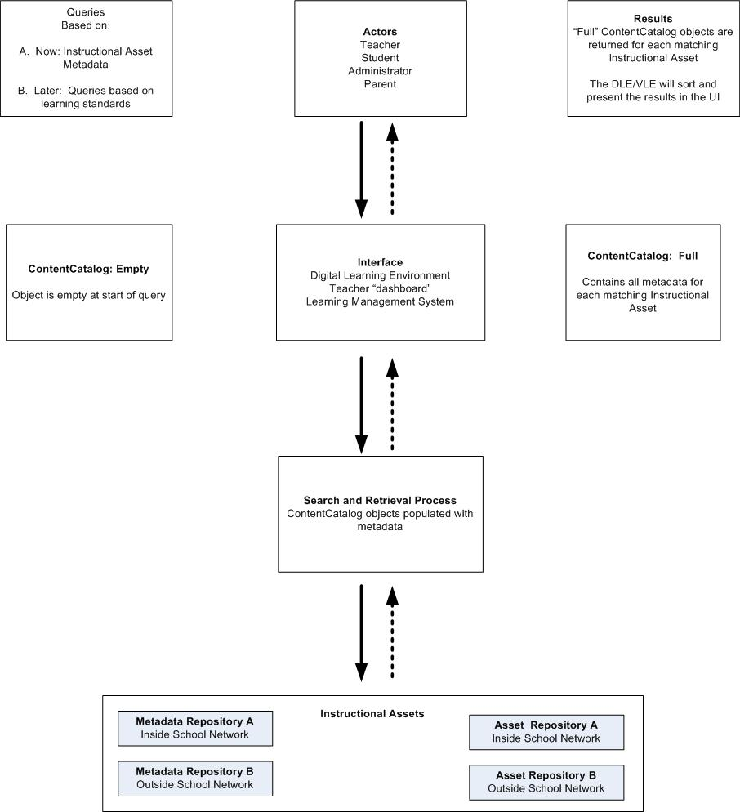

Description of the Model
The diagram on the previous page describes the relationships between the entities and processes involved in this Use Case.

Explanation of the Entities:
- “Interface” refers to any digital learning environment from which this kind of search might be initiated.
- Important details about the “Search & Retrieval Process” are not defined in this document. ISTF requests that the Tech Board provide clarification about the details of this process. See Open Issues section below, which describes issues and concerns about this process.
- “Instructional Assets” is an umbrella term for the list of SIF objects listed in that box. Any of these may be returned in the search results. For the purposes of this use case, the search is made on the metadata associated with these objects.
- “Metadata Repository” refers to a database that consists of the metadata records for a set of instructional assets. A metadata repository does not include the asset itself. Repository A lies within a school network, while Repository B is outside of a school network. This metadata can include a URI or other pointer to the location of the actual asset. More than one metadata repository from multiple sources may be involved in this scenario. Library systems are a type of metadata repository.
- “Asset Repository” refers to a database that consists of digital instructional assets. These necessarily include their associated metadata. Repository A lies within a school network, while Repository B is outside of a school network. More than one asset repository from multiple sources may be involved in this scenario.
Both kinds of repositories must have the capability to respond to query requests.

Instructional Asset Metadata Retrieval Process
The retrieval of instructional asset metadata is an 3-step process:

- User of Digital/Virtual Learning environment selects metadata or attributes as search criteria for some instructional assets (empty object)
- User gets back a list of content that meets the search criteria (full object)
- Look through list, select item(s) to be delivered (this is defined); uses refid or URL of instructional asset to return

Use Cases

Use Case 1

The Requesting Application
In this example, we expect that a teacher would be using an application like a lesson planner or a Learning Management System (LMS).

This application will be responsible for getting the search criteria from the end user and sending the Content Catalog object request to the ZIS via the application’s SIF agent. It is the responsibility of the requesting application or its SIF agent to map the teacher’s search request to the Content Catalog object elements. The requesting application would then issue either a simple object query or an extended object query depending on which the responder applications support.

The Content Catalog has been designed to allow searches using traditional criteria like title, author, and subject. The team has also added elements to allow for more K12-friendly searches. The Content Catalog has elements to define search criteria for grades, languages, and learning standards.

Searches can also be narrowed to returns results that match one specific resource type like assessments or lesson plans.

Due to the nature of the ZIS system, one Content Object query request can be sent to multiple responder applications thus providing a federated search capability. To accomplish such a search, the agent supporting the requesting application must query the ZIS to discover the providing applications and to send separate queries, one each to the different responder applications.

Here are some plain text of search requests that can be sent via the Content Catalog object:

“Return a list of all assessments whose subject is “Lincoln” and whose grade level is 10 and whose language is Spanish”

“Return a list of all resources whose titles match “Pluto””

The Responder Application

It is the responsibility of the responder application to search its repository and return the responses.

First, the providing application must register with the ZIS as a responder of Content Catalog objects. There may be more than one registered responder of the Content Catalog objects if there is more that one content repository available to be searched.

Each registered Content Catalog object responder application will receive search requests in the form of standard SIF_Query or extended queries. Once received, the application, or its SIF agent, is responsible to mapping the search criteria in the Content Catalog object elements to the application’s query.

Once a search has been completed, it is the responsibility of the responder applications, or its SIF agent, to format the results into Content Catalog objects. One object will be returned for each matching instructional asset.

Although virtually all the elements in the Content Catalog object have been defined as optional, the responder application should provide as much data in the response as possible. It should always be remembered that returned objects would probably be presented to the teacher as a search response list. The more information that is provided to the teacher the easier it will be for the teacher to select the best resources for their needs.

Besides providing the teacher with information about the resources, the providing application must provide an identifier (RefID or URL) to allow the teacher (via the requesting application) to retrieve the resource.

Content Retrieval

Providing a teacher with a search response list is only part of what needs to happen in our use case. After being presented with a search list, the teacher will probably want to retrieve a resource pointed to by the search list. The Content Catalog does not provide any mechanism for resource retrieval. That is outside the scope of the object. However, the object does provide elements that can facilitate resource retrievals via the Web or via SIF.

For content accessible via the Web, the responder application can insert a URL to the resource in the Content Catalog search response object. The requesting application would then retrieve the content via a standard HTTP call if the teacher selected a search response that contains a URL

Alternately, the content could be retrieved via the ZIS. In this scenario, the responder application would populate a REFID element in the Content Catalog object. Along with the REFID, the SIF object type must be specified. If this type of search response is selected by the teacher, the requesting application would issue a simple object query to the ZIS for the type of object specified and requesting the REFID provided.
Note: if an application provides REFIDs that reference the actual content in the response content catalog objects the application must also be a responder for that object. Also, the SIF agent must be aware that the REFID may be returned from applications in other zones. The content catalog object does not have any elements to

Interconnecting with Existing Resource Search Applications

As mentioned earlier, the new Content Catalog search object is not designed to displace other existing resource search standards. Rather, it actually may allow SIF-based applications to participate with the other standards.

For an example, a vendor might build a SIF agent that knew how to “talk” Z39.50. This agent would translate between Content Object searches and Z39.50 library applications.

Another vendor might build a SIF agent that acts like a SOAP responder of OKI repository searches. It might receive a OKI search request, translate it into Content Catalog search request and then translate the search responses. This agent would allow applications that search OKI repositories to now also search Content Catalog enabled repositories via SIF.

We will need to determine what the relationships are between the entities in these use cases. Here is an early attempt to document that:

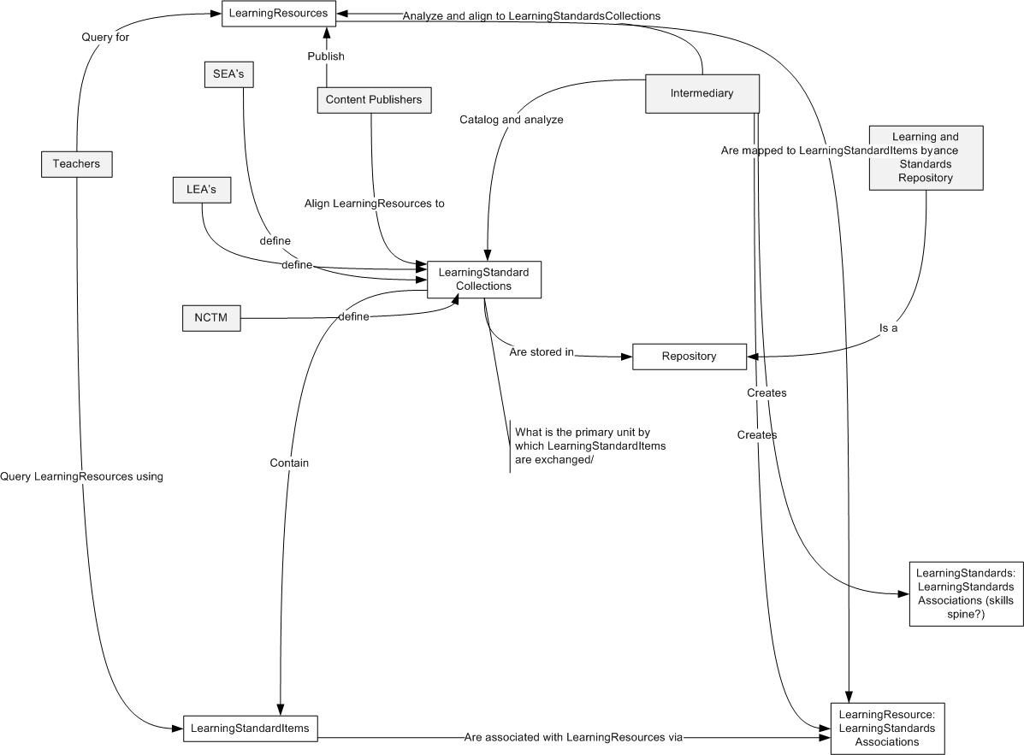

Use Case 2: Request Instructional Assets
The major use case that the team is trying to solve for is when teachers construct their lesson plans they often look for educational resources. They may be looking for lesson plans they can use or they may want to find resources such as assessments, images, books, or videos for use in their lessons. Teachers today have access to many resources but they exist is many different repositories. Teachers have access to tradition resources such as libraries along with repositories of electronic resources. The repositories may either at the school level, the district level, the state level or the national level. Resources may also be available to a teacher from vendors.

The Content Catalog object is designed to be used in this use case to provide a mechanism by which federated searches for resources can be accomplished within the SIF world.

Use Case 3: Technical Overview Use Case
This specific use case focuses on searching for Instructional Asset Metadata and/or actual Assets based on metadata identified by the user of a Digital Learning Environment.

Usecase #1 | Title: Request Content for specific instructional Assets  Use Case Number: 2008-01  History: Proposed
Use Case Type (Mandatory or Optional) | Mandatory
SIF Versions and References | SIF Implementation Specification 2.3  SIF Implementation Specification 2.4
Summary | Teachers (and other users of a digital learning environment) search for Instructional assets based on metadata assigned to those assets.  This use case illustrates how a teacher could search for Instructional Assets that could be used in her classroom.
Actors | Primary: User of Digital/Virtual Learning Environment  Secondary: Owners of Metadata and Asset Repositories
Preconditions | - One or more Metadata or Asset Repository is available and the data within them can be searched and retrieved.  - The Digital Learning Environment has a way to send a query request to the repository(ies) in the system.
Post Conditions | - The Digital Learning Environment presents a list of Instructional Assets that have the requested metadata attributes.  - Actual assets are not presented / loaded / played in this scenario, but hyperlinks (URIs) to the locations of the Assets are included in the metadata that is presented.
Action Steps | - Teacher is teaching a physics concept and wants to find Instructional Assets that relates to that concept.  - Using the User Interface of her Digital Learning Environment, the teacher identifies the physics concept and other related metadata (such as learning style, media type, etc.) she is looking for.  - Using the process described above, the query message is sent to the repository(ies).  - The repository(ies) receives the query.  - The repository(ies) compile lists of Instructional Assets and associated metadata that match the query criteria.  - The instructional assets and associated metadata are packaged into ContentCatalog objects and sent to the Digital Learning Environment.  - The Digital Learning Environment receives the list of Instructional Assets and associated metadata.  For context, these subsequent actions occur in the digital learning environment:  - The Digital Learning Environment parses/sorts the list of Instructional Assets and associated metadata according to the teacher’s search criteria or other software-specific features.  - The Digital Learning Environment displays the sorted list to the teacher.
SIF Mandatory Objects | The known objects involved in this scenario include:  6.3.1 Assessment  6.10.1 Activity  6.10.4 LearningResource  6.10.8 Lesson  Library objects to be named
SIF Optional Objects | To be determined.

Open Issues
- There is potential redundancy of metadata for objects involved
  - Examples: (need to add)
- Lack of uniformity in metadata
  - Difficulty of making returned results appear in a consistent format if metadata varies across the entire set of returned results
  - Examples: (need to add)
- Heterogeneous systems (systems in which there is more than one vendor supplying Instructional Assets (metadata and / or digital assets)
  - Inconsistent use of metadata
  - Differing learning standards systems
- Are there other objects that need to be developed to make this scenario possible?
- Is this a publish/subscribe model?
- Mark Ward: Can SIFFrom or SIFTo be used?

ContentCatalog Object Definition

The curriculum responder makes available a “catalog” of relevant instructional assets in this format. This detail should succinctly identify curriculum whether it is an assessment, Learning Resource, Activity or Lesson.

There is the beginning of a metadata recommendation in the Appendices but that is a separate submission than the ContentCatalog Object that will be separated out based on Technical Board feedback.

ContentCatalog Definition Table.

 | Element/@Attribute |  | Attribute | Description | Type
 |  | ContentCatalog |  | This object contains information related to learning resources that can be searched for and retrieved from content repositories.
@ |  | xml:lang | M | The default language used in this ContentCatalog object.
 |  | ContentObject | M | The learning object.
 |  | ContentObject / SourceObject | O | GUID assigned to the source object. | IdRefType
@ |  | SIF_RefObject | M | The name of the Source SIF object to which the GUID relates | Values:  Assessment  LearningResource  Activity  Lession
 |  | ContentObject / Location | O | Description of location of resource, i.e. location in library or URL, community resource, outside resource supplier. | xs:string
@ |  | ReferenceType | M | A qualifying attribute for the Location payload. If ReferenceType is "URI", the payload contains a web address where the resource can be found. | xs:token
 |  | Status | O | Describes availability status of resource, e.g. "checked out." | xs:normalizedString
 |  | Title | O | Title of the resource, e.g., "The Civil War …" | xs:string
 |  | Description | O | Description of the resource, e.g., "This textbook is intended for grade 4 social studies students and addresses..." | xs:string
 |  | Author | O | Name of individual, organization or company that created the resource | xs:normalizedString
 |  | LanguageCode | O | The language used by the content to communicate to the Student | NISOZ3953LanguageCodesType
 |  | GradeLevels | O |  | GradeLevels
 |  | SubjectAreas | O |  | List
 |  | SubjectAreas / SubjectArea | OR |  | SubjectArea
 |  | MediaTypes | O | Resource media types | List
 |  | MediaTypes / MediaType | OR | MIME type [MIME] based on IANA registration (see RFC2048) or 'non-digital' | xs:token
 |  | LearningStandards | O | References to Learning Standards | List
 |  | LearningStandards / Document | OR | A curriculum standards document or the like published by a national, state, district, school site, professional association or other interested party. | xs:normalizedString
 |  | LearningStandards / Document / Title | O | Name of standard document, i.e., "Washington Essential Academic Learning Requirements." | xs:normalizedString
 |  | LearningStandards / Document / StandardsSettingBody | O | The name of the state or organization that authored and manages updates to the standards document (i.e., NCTM, Ohio Department of Education). | xs:normalizedString
 |  | LearningStandards / Document / StandardsSettingBody / Country | O | This represents the subject or content area this curriculum addresses. | Country
 |  | LearningStandards / Document / StandardsSettingBody / StateProvince | O | This represents the grade level(s) this specific curriculum will address. | StateProvince
 |  | LearningStandards / Document / StandardsSettingBody / NCESId | O |  | NCESId
 |  | LearningStandards / Document / StandardsSettingBody / SettingBodyName | O | This is the text version of the organization's name. | xs:normalizedString
 |  | LearningStandards / Document / Statement / StatementCode | O |  | List
 |  | LearningStandards / Document / StatementCodes / StatementCode | OR | An alphanumeric ID code as defined by the organization to identify the statement. | xs:string
 |  | InstructionalLevel | O | An indication of the general nature and difficulty of instruction provided. | NCES0437InstructionalLevelType
 |  | TechnicalRequirements | O | Applications, OS, and network requirements for activity if applicable. | List
 |  | TechnicalRequirements / TechnicalRequirement | OR | Applications, OS, or network requirement for activity. | xs:string
 |  | Duration | O | Time required to complete the activity. | xs:unsignedInt
@ |  | Units | M | Unit of time of the Duration value. | values:  week  day  hour  minute  second
 |  | CurriculumHierarchy | OR | Description of additional curriculum hierarchical level
 |  | CurriculumHiearchy/ Level | O | Number reference of Curriculum Hierarchy | xs:string
 |  | CurriculumHiearchy/ Description | O | Description of Curriculum Hierarchy level | xs:string
 |  | CurriculumHiearchy/ ParentLevel | O | Parent Level | xs:string
 |  | Prerequisites | O | Skills or competencies the student must have to engage in activity. | List
 |  | Prerequisites / Prerequisite | OR | Skill or competency the student must have to engage in activity | xs:string
 |  | Adaptations | O | Adaptations necessary for target students (508) | xs:string
 |  | Size | O | The size of the learning content objects. | xs:string
 |  | Cost | O | The price of the object requested | xs:string
 |  | SIF_Metadata | O |  | SIF_Metadata
 |  | SIF_ExtendedElements | O |  | SIF_ExtendedElements

XML Example

<ContentCatalog xml:lang="en">
<ContentObject>
<Location ReferenceType=”URI”>
http://myserver.mydomain.com/content/civil_war_photos.pdf
</Location>
<Status>Available</Status>
<Title>The Civil War in Photos</Title>
<Description>A collection of Civil War Photos</Description>
<Author>John Smith</Author>
<LanguageCode>eng</LanguageCode>
<GradeLevels>
<GradeLevel>
<Code>09</Code>
</GradeLevel>
<GradeLevel>
<Code>10</Code>
</GradeLevel>
<GradeLevel>
<Code>11</Code>
</GradeLevel>
</GradeLevels>
<SubjectAreas>
<SubjectArea>
<Code>04</Code>
</SubjectArea>
</SubjectAreas>
<MediaTypes>
<MediaType>x-application/pdf</MediaType>
</MediaTypes>
<LearningStandards>
<Document>
<Tile></Title>
<StandardsSettingBody>
<Country>US</Country>
<StateProvince>OH</StateProvince>
<NCESId>12345</NCESId>
<SettingBodyName>Ohio Department of Education</SettingBodyName>
<StandardsSettingBody>
<StatementCodes>
<StatementCode>US History.2.03.a</StatementCode>
</StatementCodes>
</Document>
<Document>
<Tile></Title>
<StandardsSettingBody>
<Country>US</Country>
<StateProvince>UT</StateProvince>
<NCESId>67890</NCESId>
<SettingBodyName>UT Department of Education</SettingBodyName>
<StandardsSettingBody>
<StatementCodes>
<StatementCode>US History.4.89</StatementCode>
</StatementCodes>
</Document>
</LearningStandards>

<InstructionalLevel>
<Code>0571</Code>
</InstructionalLevel>
<TechnicalRequirements>
<TechnicalRequirement>
<Duration @units=”minute”>10</Duration>
</TechnicalRequirement>
</TechnicalRequirements>
<Size>100mb</Size>
</ContentObject>
</ContentCatalog>

Appendices

Glossary: Terms & Concepts in this Document
- Instructional Asset: Generic term that refers to any asset that could be used in a classroom setting or learning environment. These include but are not limited to:
  - 6.3.1 Assessment
  - 6.10.1 Activity
  - 6.10.4 LearningResource
  - 6.10.8 Lesson
  - Library object(s) to be defined or named

- Digital /Virtual Learning Environment: Generic umbrella term that refers to any kind of electronic interface, “dashboard,” or instructional content delivery platform with which teachers, learners, or parents interact. Examples include: “Learning Management Systems,” and products such as Moodle, DrupalED, SchoolNet, ClassLink, or Blackboard.
- Metadata: An umbrella term that refers to any descriptive information about Instructional Assets, and includes SIF Metadata as well as other attributes that describe Instructional Assets. Metadata can describe digital as well as non-digital Instructional Assets.
- Metadata Repository: A database of Instructional Asset metadata. This repository may reside within a school network or outside the school network. Library systems are a kind of instructional asset metadata repository.
- Asset Repository: A database of digital instructional content. This content can be found via a search initiated by a Digital/Virtual Learning Environment. This repository may reside within a school network or outside the school network.Library systems may be a kind of Asset Repository.

History
A content catalog is not a new concept. Rather the Content Catalog object is a SIF compliant implementation of older, proven concepts.

Everyone is familiar with library card catalogs. Library books are cataloged by title, author and subject.

In the 1970s an effort was launched to make library card catalogs electronic and to make them searchable outside of the brick and mortar library building. This effort spawned the Z39.50 standard. Although this standard predates the Internet it is still in use today. Essentially, the library patron looking for a book types their search criteria into a computer application. This application then sends the search query to another computer application in a library using the Z39.50 protocol. The catalog is searched at the library electronically, and a list of matching catalog entries is returned. The response consists of the catalog entries (title, author, subject, etc.), not the actual book. Although the Z39.50 spec is somewhat dated there are ongoing attempts to modernize it. Even still, the concept of an electronic catalog search remains relevant.

A more modern take on the topic has been put in place by the OKI standards body in their Repository API SOAP interface specification.

The ISTF team does not expect the Content Catalog object to displace these other standards, but rather the new object will allow the same sorts of catalog search concepts to occur via a SIF Zone and to search over more varied content types.
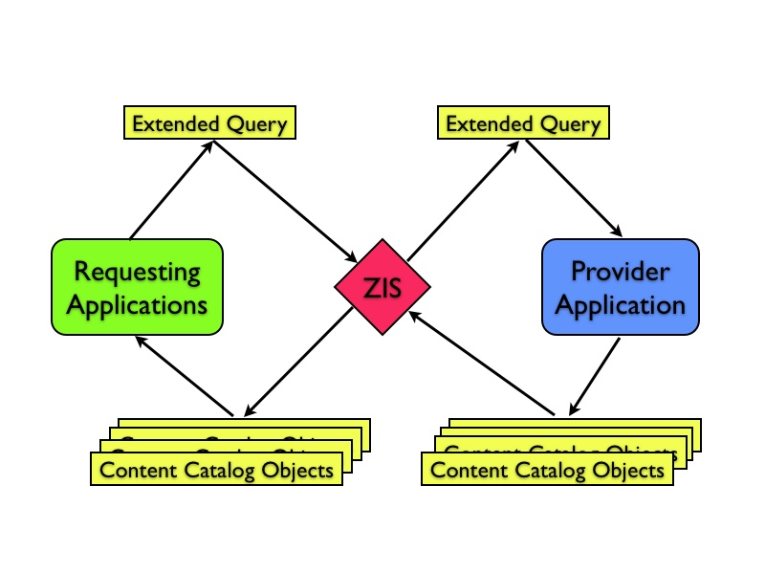

Possible Recommended changes to Education Filter Object

The curriculum responder publishes their catalog of learning objects through this format, which allows them to describe their curriculum sufficiently to inform the requestor of availability. This detail should succinctly identify curriculum whether it is an assessment, Learning Resource, Activity or Lesson.

This format accommodates providers who add more granular curriculum by extending the State Standard hierarchy beyond what is indicated by the LearningStandardItem.

Legend
Current Education Filter
Suggested additions

Object | Elements | Attribute | Description
 | EducationFilter
 | MediaTypes | O | Allows an object or query to be tagged with MIME types.
 | MediaTypes/MediaType | MR
 | GradeLevels | O | Applicable grade levels as defined by SIF.
 | SubjectAreas | O | This allows subject areas to be associated with an object or query. Although there could be overlap with LearningStandardItems, it is anticipated there will be use cases where LearningStandardItem objects may not exist or may not be available, and data may need to be tagged with high-level subject areas.
 | SubjectAreas/SubjectArea | MR
 | InterestLevels | O | InterestLevels is designed to represent the grade level for which the content is created. For example a tenth grader is at a third grade level in Algebra. You would want to present the content at a third grade level, but in a tenth grade context or interest level.
 | InterestLevels/InterestLevel | MR
 | LearningStandardItems | O | Allows any SIF object to be correlated to learning standards.
 | LearningStandardItems/LearningStandardItemRefId | MR
 | BloomsTaxonomyLevels | O
 | BloomsTaxonomyLevels/BloomsTaxonomyLevel | OR
 | MultipleIntelligences | O
 | MultipleIntelligences/MultipleIntelligence | OR
 | InstructionalStrategies | O
 | InstructionalStrategies/InstructionalStrategy | OR
 | Elements below are optional repeatable
 | Language | O | The language used by the content to communicate to the Student
 | Adaptations | O | Adaptations necessary for target students (508)
 | Format | O | The technical data type of associated objects. IE mpeg, html.
 | Required Technology | O | Can be a number of specifications, operating system, browser type/version, computer constraints, eg MAC, PC
 | Duration | O | The typical duration to complete the content
 | Prerequisites | O | Previous Curriculum expectation
 | Size | O | The size of the learning content objects.
 | Cost | O | The price of the object requested
 | Pointer to Content |  | In learning resource package URI
 | Description |  | Summary in 2.4
 | Copyright

